Feedback 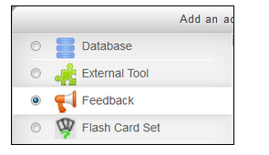
Feedback allows you to create and conduct surveys. You can create different kinds of questions: multiple choice, short answer, etc. You can share the results of the Feedback with the students or keep them confidential.

Contents
- To Add Feedback
- To Add Questions
- To Edit a Question
- Dependence item
- Review Analysis
- To See Individual Response
- To Delete Entry
- To Show non-respondents
- To Save as a Template
- To Use a Template
- To Delete a Template

To Add Feedback
- Go to the course home page.
- Click on the Turn editing on button at the top right of the page.
- Click Add an activity or resource.
- Click on the radio button next to Feedback and click on the Add button.

- The "Adding a new Feedback page" will appear.
- Type a Name and Description. Ensure the Name clearly identifies the activity for the students.
Do not put the description on the course home page (check box) unless absolutely necessary to ensure the course page does not become cluttered with course details and thus prevent easy student navigation.
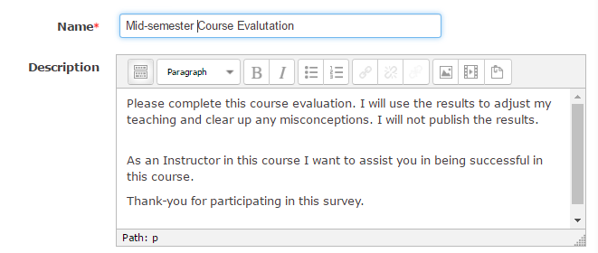
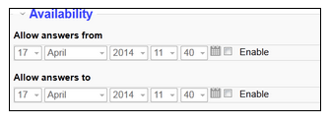
- Availability: Set the opening time and the closing time. If you uncheck the checkbox, there is no time limit.

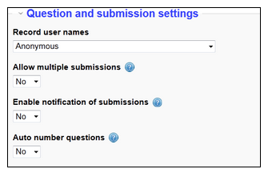
- Question and submission settings:

Record user names: Record User Name affects only what the teacher sees. Students do not see responses.
Allow multiple submissions: If enabled for anonymous surveys, users can submit feedback an unlimited number of times.
*Moodle does not allow you to change the Allow multiple submissions setting after someone has answered the Feedback activity.
Enable notification of submissions: If enabled, the instructor will receive an email notification.
Auto number questions: Automated numbers for each question.
- After submission
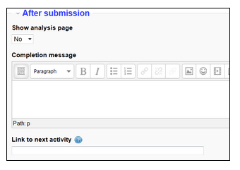
Show analysis page: If enabled, summary results can be shown to students.
Completion message: This text will be displayed immediately after students submit their answers. You can use this page to explain what happens after the activity.
Link to next activity: If you want the students to go to a specific page after they submit the feedback, type the URL. If you leave this blank, the Continue button will take the students back to the course home page.
- Click on the Save and return to course or Save and display button.
To Add Questions
- Click on the Feedback activity on the course home page.
You will see the Feedback page.
- Click on the Edit questions tab.
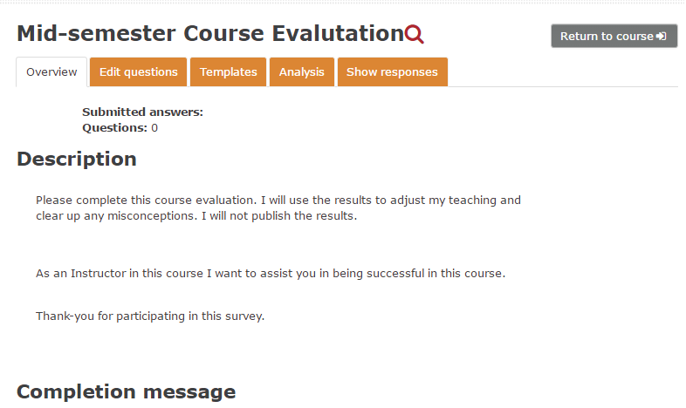
- You will see the Add question to activity page. Click on the Select box.

- Choose a question type from the dropdown menu.
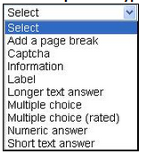
- Question Types -
• Add a page break: Insert a page break.
• Information: You can insert information about the feedback into the form.
◊ Response time: The date and time the user submitted.
◊ Course: The short name of the course.
◊ Course category: The course category name.
• Label: You can type an explanation or instructions, etc.
• Longer text answer: You can decide the width and number of lines in the text box.
• Multiple choice: There are three types of multiple choice questions.
◊ multiple choice - single answer: The student can select only one response by clicking the radio button.
◊ multiple choice - multiple answers: The student can select as many responses as they want by clicking the checkbox.
◊ multiple choice - single answer allowed (drop down list): The student can select only one response from the dropdown list.
• Multiple choice (rated): This is a multiple choice - single answer question. When the instructor looks at the analysis for this question, the average will be displayed. If the instructor exports the results to Excel, the rating numbers will be also exported.
• Numeric answer: You can set a range of values.
• Short text answer: You can specify the size and maximum characters of the text box.
* Currently the Captcha function is not available.
- Required: If you require the answer to this question, check this checkbox.
- Question: Type the question.
- Label: Type a Label name. The label will become a dependence item for the dependent question.
- Dependence item: It is possible to show an item depending on the value of another item. Choose Label from the list.
- Dependence value: Type the value.
- Click on the Save question button.
You will see the Preview page.
To Edit a Question
- Click on the Feedback activity from the course home page.

- Click on the Edit questions tab. Click on the Edit question icon.
- Modify the question.
- Click on the Save changes to question or Save as new question button.
Dependence item

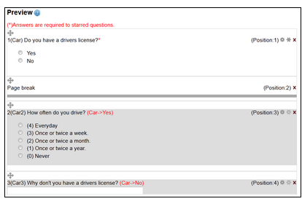

- Create a question on which another item will depend.
- Add a page break.
- Add the questions dependent on the value of the item created before.
- Choose the item from the list labelled "Dependence item".
- Type the required value in the text box labelled "Dependence value".
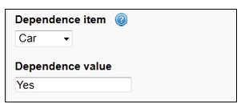
- Click on the Save question button.
Review Analysis
- Click on the Feedback activity from the course home page.
- Click on the Analysis tab.
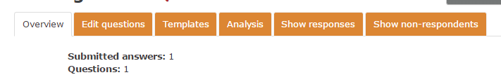
You will see the result of the feedback. If you want to export the result to Excel, click on the Export to Excel button.
To See Individual Response
- Click on the Feedback activity from the course home page.
- Click on the Show responses tab.
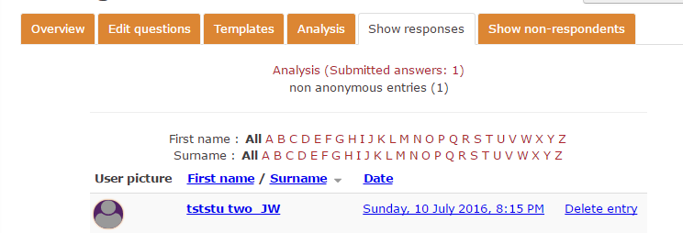
- Click on the date next to student name. You will see the response.
* If you set the Feedback to anonymous, click on the Show responses button next to Anonymous entries(#); then click Show response next to "Response number: #".
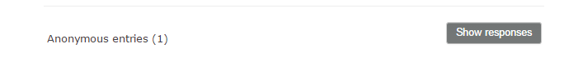
- Click on the continue button, which takes you to the responses page.
To Delete Entry
- Click on the Feedback activity from the course page.

- Click on the Show responses tab.
- Click on Delete entry on the right side of the student name.
- Click on the Yes button.

To Show Non-Respondents
- Click on the Feedback activity from the course page.
- Click on the Show non-respondents tab.
You will see the non-respondents list.
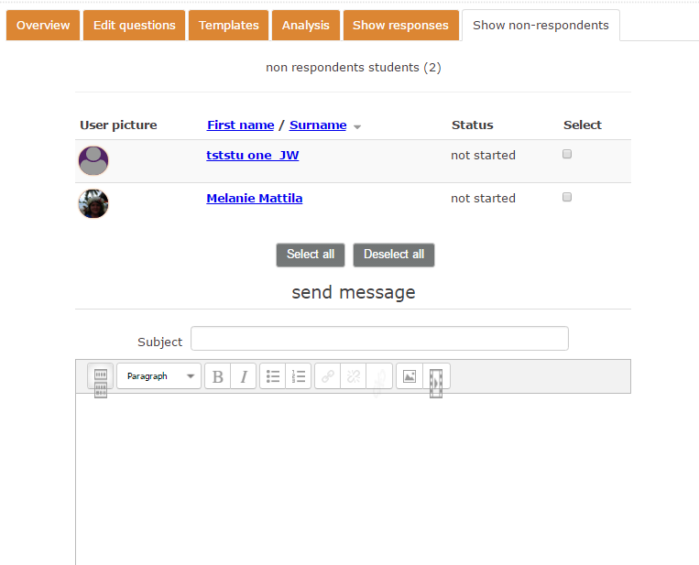
* You can send a message to them.
1. Select the students by clicking the select checkbox or click on the Select all button.
2. Type a Subject and a message.
3. Click on the send button.

To Save as a Template

After creating a Feedback activity, you can save it as a Template.
1. Click on the Feedback activity from the course page.
2. Click on the Templates tab.
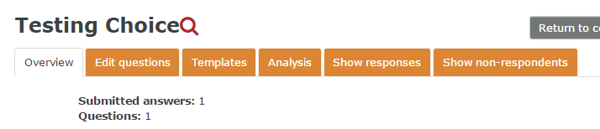
- Type a Name.
- Click on the Save as new template button.
To Use a Template
- Click on the Templates tab.
- Click on the Choose box of "Use a template".
- Choose the template name from the dropdown menu.
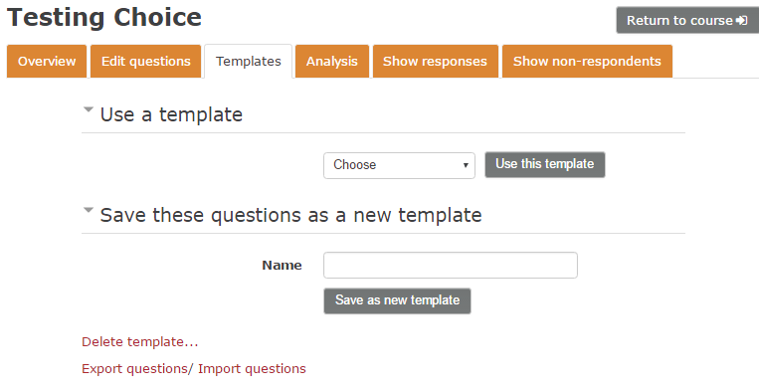
- Click on the Use this template button.
- Select "Delete old items" or "Append new items".
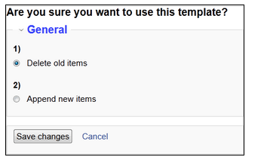
Delete old items: If you have already created some questions for the Feedback activity, Moodle will delete them and add questions from the template that you choose to the current Feedback activity.
Append new items: If you have already created some questions for the Feedback activity, Moodle will add questions from the template that you choose to the current Feedback activity.
- Click on the Save changes button.

To Delete a Template
- Click on the Templates tab.
- Click Delete template.
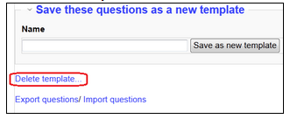
The Template list will show up.
- Click on the Delete template button next to the template name.
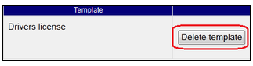
- Click on the Yes button.
- Click on the Back button.

